**INFO 5707 – DATA MODELING FOR INFORMATION PROFESSIONALS**

**TERM PROJECT**

**PROJECT TITLE: ONLINE FOOD ORDERING SYSTEM (GRUB HUB)**

**TEAM NAME: GROUP-14**

**TEAM MEMBERS:**

1. Srujan Bandla- 11552131 (TEAM CO-ORDINATOR)
2. Kandhikya Bangaluru - 11557752
3. Sai Santhosh Reddy Gantla- 11551989
4. Arthi Reddy Annadi - 11422019

**TITLE OF THE PROJECT*:*** **GRUBHUB** (ONLINE FOOD ORDERNING SYSTEM).

**OBJECTIVE:**

This project is intended for online food ordering management, where a number of factors are taken into account from the time food is ordered to delivery, including login information, restaurant names, locations, menus, customer information, customer support, order status, delivery status, payment method used, employee information, and saved card information. Manually gathering and assembling the data would be an extremely time-consuming task for the management. A database management system would be helpful to simplify this procedure and make it easier. The GRUBHUB administration has access to this system with the required unique credentials.

**SCOPE:**

The primary goal of the project is to create a solid database with all the data pertaining to patrons and eateries. It includes the customer's order information, his previous orders, his payment method, his address, and all other information. The GRUBHUB team may analyze these data and provide the customer with helpful recommendations based on past orders. It will also be quite beneficial to keep track of all the transactions. Additionally, users can use this to examine the details of the meal they've previously ordered, including what restaurant they came from. Also, GRUBHUB administration will have all the access of the customer information and restaurant information.

**USER REQUIREMENTS:**

The system will have the following features:

The required Customer information is as follows:

1. Have the access to order food from various restaurants.
2. Have record of the Customer Previous Order Details (Restaurant Name, Food Name, Time and Date)
3. Saved cards in the account
4. To watch the ratings and reviews of the restaurant.
5. Previously raised Complaints / Concerns
6. Delivery Address, Location
7. Order status, Delivery Status.
8. Delivery Person Name and the contact information.

The required information of the Restaurants is as follows:

1. Can Read and Edit the Availability of the Food Menu and prices.
2. Order Details like (ORDER ID, ITEM NAME AND CUSTOMER NAME)
3. Access to Delivery Agent Name and contact details.
4. Access to edit the Minimum Order Price and Delivery Time

The required information of the GRUBHUB Administration is as follows:

1. Can Access to each individual Customers Information.
2. Can Access to each individual Restaurant’s Information.
3. Have access to READ/ WRITE/ EDIT/ DELETE information from the database.
4. Have access to all the transaction details (FOR REFUND OR ADJUSTMENTS)
5. Have access to customer support and employee information.

**Business Rules:**

1. Customer can order food from only one restaurant at a time.
2. The customer must provide a valid address and valid payment mode to make an order.
3. Preparation of the food will be started once the order is successfully placed.
4. A valid debit / credit card must be provided while placing an order.
5. Customer support team must have the access for the customer’s account.
6. Customer can raise a complaint on their orders.
7. User must have the access for the order status and delivery person information.
8. Restaurant can have the access to update the menu and prices
9. Restaurant must have a valid address, phone number, Opening Time and closing Time.
10. A order can consists of many items and it should be from single restaurant at a time.
11. The payment method should be same in a single order.
12. Delivery agent can pick N number of orders and delivery should be done as per time stamp.
13. Customer can order food from various restaurant and to different locations.
14. There will be a unique Id for every payment.

**Entity-Relationship Diagram (ERD) of the system: REVISED**

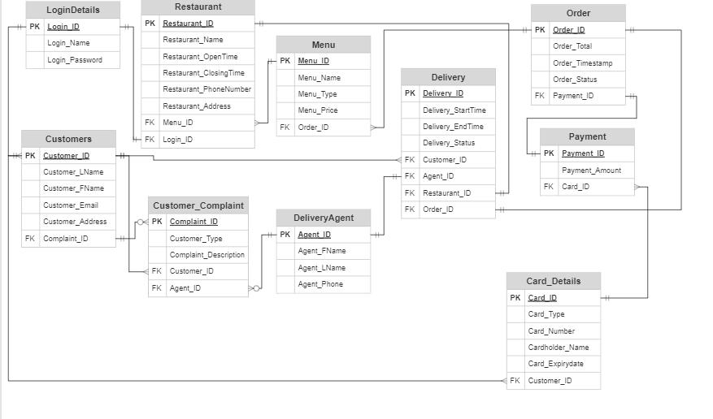

**Data Dictionary:**



**Queries:**

**Creating Database:**

* The database is first created in database schema with name ‘GRUBHUB’.
* The tables are then created in the database created.

Create Database GRUBHUB;

Use GRUBHUB;

**Creating Tables:**

In our ERD design there are total of 10 tables. Below we are creating tables, inserting values into the tables and performing some queries on the data.

**LOGIN TABLE:**

**Creating Table:**

CREATE TABLE loginDetails (

Login_ID varchar(25) NOT NULL ,

Login_Name varchar(25) NOT NULL ,

Login_Password varchar(255) NOT NULL,

PRIMARY KEY (Login_ID)

);

**INSERTING DATA RECORDS IN TABLE :**

INSERT INTO loginDetails VALUES ('SK123', 'SANJAY KUMAR','NEW1234');

INSERT INTO loginDetails VALUES ('AM678', 'RAMANJI','88776WE');

INSERT INTO loginDetails VALUES ('GJ452', 'SHANKAR','999UHFDZX');

INSERT INTO loginDetails VALUES ('ZE876', 'SAIRAM','HHGG677');

INSERT INTO loginDetails VALUES ('SR987', 'SREENATH','8888GHF');

INSERT INTO loginDetails VALUES ('MO4321', 'MOUNICA','JJHGGHGHG');

INSERT INTO loginDetails VALUES ('SN7643', 'SUNNY','HBGHG6GX');

INSERT INTO loginDetails VALUES ('SU5321', 'SUMANTH','JHHGYG677');

INSERT INTO loginDetails VALUES ('DO876', 'DODDA','JHGHBHGRGVGF5');

INSERT INTO loginDetails VALUES ('GO765', 'GOUTHAM','8887HGDD');

INSERT INTO loginDetails VALUES ('NEE654', 'NEETHIPUDI','UHTT566');

INSERT INTO loginDetails VALUES ('NA876', 'NAREN','JKBHGHGUUTRE');

INSERT INTO loginDetails VALUES ('GU365', 'GURUSAI','KKCSE12');

INSERT INTO loginDetails VALUES ('DH543', 'DHEERAJ','8887543R');

INSERT INTO loginDetails VALUES ('KR954', 'KRISHNA SAI','LLLY564RD');

INSERT INTO loginDetails VALUES ('JA4321', 'JATIN','LLJGGFFS6F');

INSERT INTO loginDetails VALUES ('HE789', 'HEMANTH','FFFSDEEC67');

INSERT INTO loginDetails VALUES ('GA543', 'GAYATHRI','77YGDFV');

INSERT INTO loginDetails VALUES ('AN541', 'ANUSHA','99HH45G');

INSERT INTO loginDetails VALUES ('RA987', 'RAMYA','88HHGG7612');

INSERT INTO loginDetails VALUES ('NE678', 'NEERAJ','99HFE45');

INSERT INTO loginDetails VALUES ('SR897', 'SREEKAR','88YYGHF');

INSERT INTO loginDetails VALUES ('VA978', 'VASAVI','IUUHUIG67N');

INSERT INTO loginDetails VALUES ('AS436', 'ASHWATH','UUGG567GFF');

INSERT INTO loginDetails VALUES ('SU677', 'SURAJ','887UHGF');

**Screenshot of the data:**

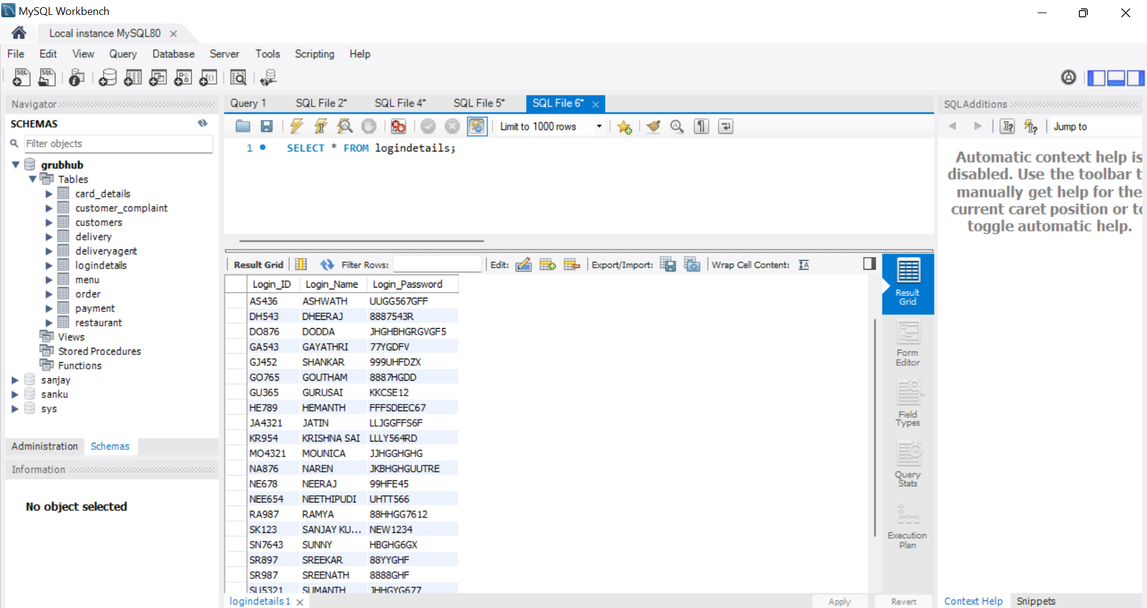

**Explanation:** The above table loginDetails describes the login credentials of customer.

**Customers Table:**

**Creating Table:**

CREATE TABLE customers (

Customer_ID varchar(255) NOT NULL,

Customer_LName varchar(255) NOT NULL,

Customer_FName varchar(255) NOT NULL,

Customer_Email varchar(255) NOT NULL ,

Customer_Address varchar(255) NOT NULL ,

Complaint_ID varchar(255) ,

PRIMARY KEY (Customer_ID));

Alter table customers add FOREIGN KEY (Complaint_ID) REFERENCES Customer_Compliant( Complaint_ID);

**INSERTING DATA RECORDS IN TABLE :**

INSERT INTO customers VALUES ('SU677', 'KUMAR','SURAJ','suraj@gmail.com','4211 west minster street','1');

INSERT INTO customers VALUES (' AS436', 'Kukkadapu','ASHWATH','ashwath@gmail.com','bbStreet', ' ');

INSERT INTO customers VALUES (' VA978', 'K','VASAVI','vasavi@gmail.com','42 street', '3');

INSERT INTO customers VALUES (' SR897', 'S','SREEKAR','sreekar@gmail.com','uc denton ','2');

INSERT INTO customers VALUES (' NE678', 'KUMAR','NEERAJ','neeraj@gmail.com','Bonnie Green','4');

INSERT INTO customers VALUES (' RA987', 'RAMYA','S','ramya@gmail.com','square nine','5');

INSERT INTO customers VALUES (' AN541', 'ANUSHA','SINGH','anusha@gmail.com','DENTON',' ');

INSERT INTO customers VALUES (' GA543', 'GAYATHRI','NIKITHA','gayathri@gmail.com','AVENUE A',' ');

INSERT INTO customers VALUES (' HE789', 'KUMAR','HEMANTH','hemanth@gmail.com','avenue b',' ');

INSERT INTO customers VALUES (' JA4321', 'JATIN','T','jatin@gmail.com','200 s bonnie brae',' ');

INSERT INTO customers VALUES (' KR954', 'KrishnaSai','BOYINAPALLY','krishna@gmail.com','400 west',' ');

INSERT INTO customers VALUES (' DH543', 'Gupta','dheeraj','dheeraj@gmail.com','avenue c',' ');

INSERT INTO customers VALUES (' GU365', 'GURUSAI','M','guru@gmail.com','avenue d',' ');

INSERT INTO customers VALUES (' NA876', 'Naren','M','naren@gmail.com','Bonnie Brae st',' ');

INSERT INTO customers VALUES (' NEE654', 'NEETHIPUDI','G','neethipudi@gmail.com','avenue c',' ');

INSERT INTO customers VALUES (' GO765', 'GOUTHAM','K','goutham@gmail.com','west hickory',' ');

INSERT INTO customers VALUES (' DO876', 'DODDA','S','dodda@gmail.com','mark at denton',' ');

INSERT INTO customers VALUES (' SU5321', 'SUMANTH','S','sumanth@gmail.com','bg apartments',' ');

INSERT INTO customers VALUES (' SN7643', 'SUNNY','DD','sunny1@gmail.com','UNT REC',' ');

INSERT INTO customers VALUES (' MO4321', 'MOUNICA','M','mounica@gmail.com','GAZEBO APARTMENTS',' ');

INSERT INTO customers VALUES (' SR987', 'SREENATH','G','sreenath@gmail.com','mark of denton12',' ');

INSERT INTO customers VALUES (' ZE876', 'SAIRAM','M','sairam@gmail.com','200 s b st',' ');

INSERT INTO customers VALUES (' GJ452', 'SHANKAR','V','shankar@gmail.com','bunk denton',' ');

INSERT INTO customers VALUES (' AM678', 'RAMANJI','K','ram@gmail.com','Gazebo street',' ');

INSERT INTO customers VALUES (' SK123', 'SANJAY KUMAR','KOTA','sanjay@gmail.com','820 s 35',' ');

**Screenshot of the Data :**

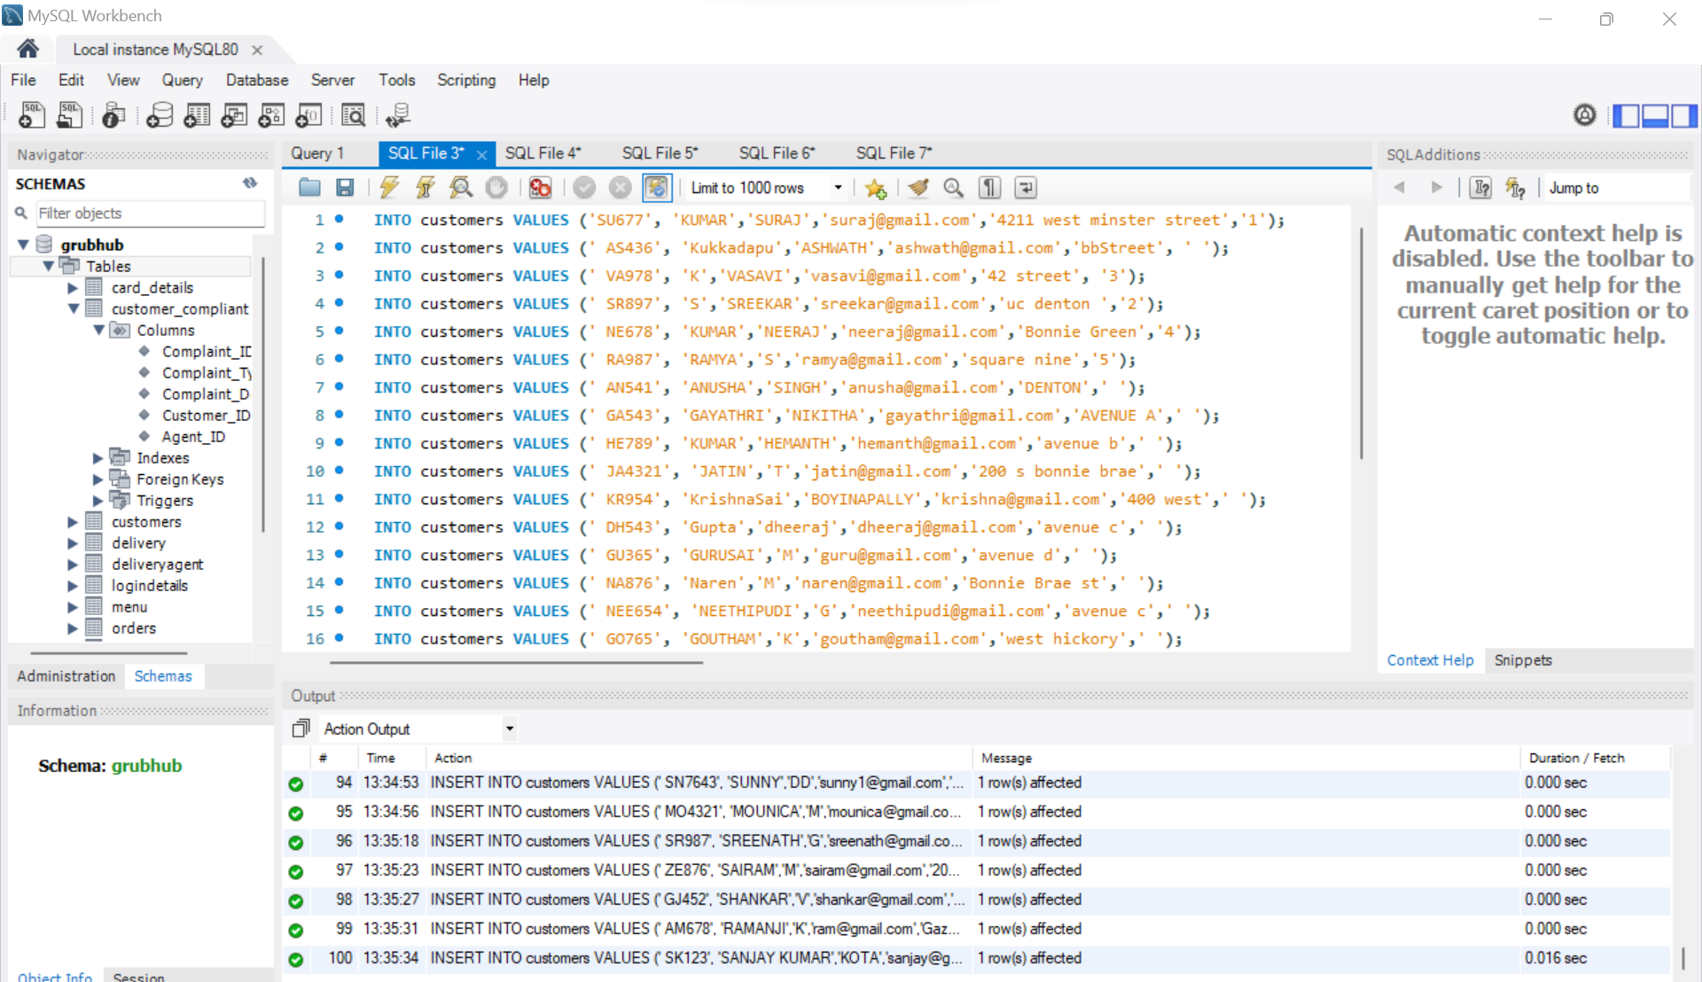

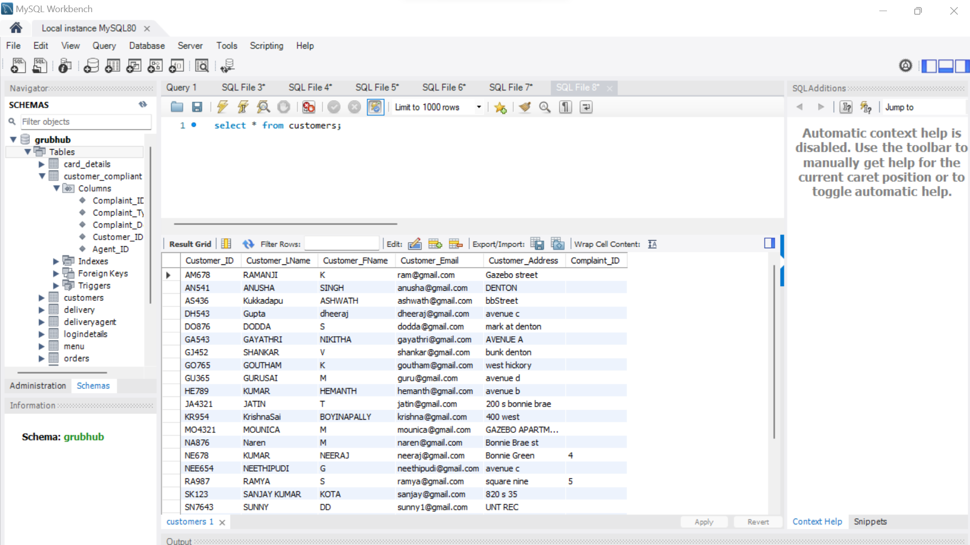

**Explanation:** The above table customers is having details of the customers.

**Customer_Complaint Table :**

**Creating Table :**

CREATE TABLE Customer_Compliant (

Complaint_ID varchar(255) NOT NULL,

Complaint_Type varchar(255) NOT NULL,

Complaint_Description varchar(255) NOT NULL,

Customer_ID varchar(255) NOT NULL,

Agent_ID varchar(255) NOT NULL,

PRIMARY KEY (Complaint_ID),

FOREIGN KEY (Customer_ID) REFERENCES Customers (Customer_ID));

alter table Customer_Compliant add FOREIGN KEY (Agent_ID) REFERENCES deliveryagent (Agent_ID);

**INSERTING DATA RECORDS IN TABLE:**

INSERT INTO customer_compliant VALUES ('1', 'QUALITY ISSUES','FOOD NOT COOKED WELL','SU677','DA1');

INSERT INTO customer_compliant VALUES ('2', 'MISSING ITEM','ONE OF THE ITEM IS NOT RECEIVED','SR897','DA2');

INSERT INTO customer_compliant VALUES ('3', 'INCORRECT ITEM','RECEIVED WRONG ITEM','VA978','DA3');

INSERT INTO customer_compliant VALUES ('4', 'ORDER ARRIVED LATE','THE ORDER RECEIVED 25 MINS LATE','NE678','DA4');

INSERT INTO customer_compliant VALUES ('5', 'ORDER NEVER RECEIVED','MY ORDER WAS NOT RECEIVED','RA987','DA5');

**SCREENSHOT OF THE DATA:**

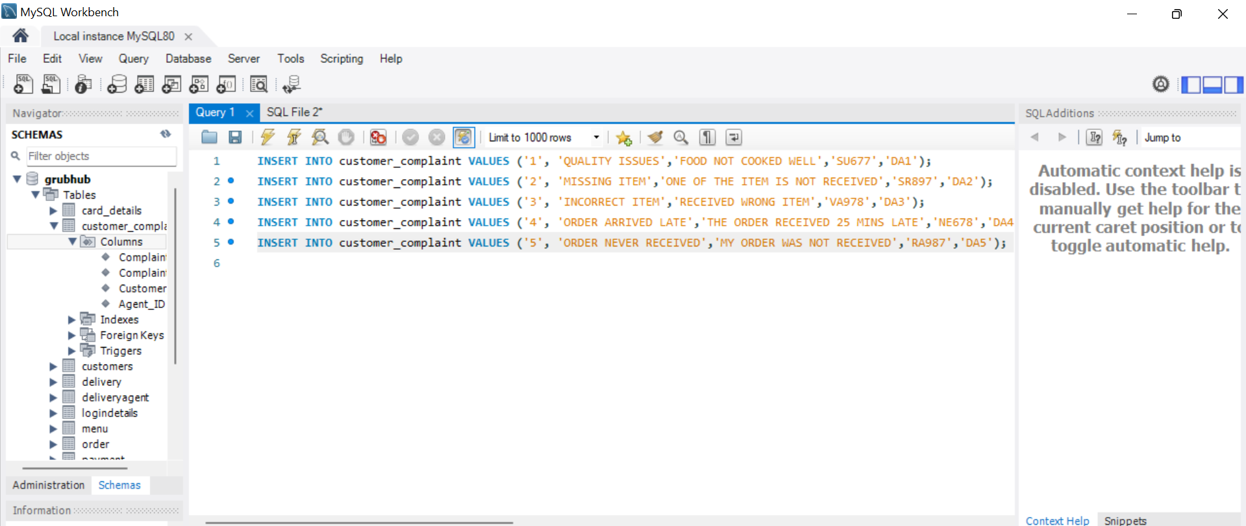

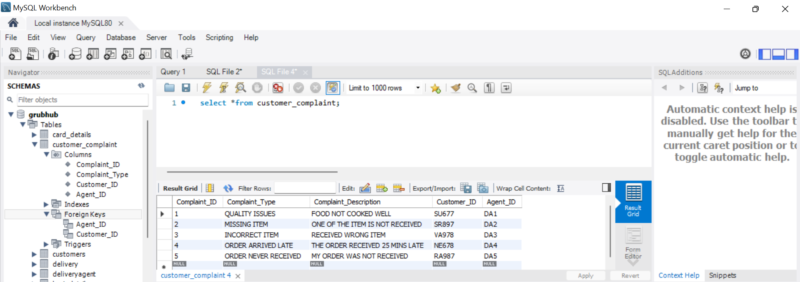

**Explanation:** The above table shows complaints raised by the customers.

**DELIVERY AGENT TABLE:**

**Creating Table:**

CREATE TABLE DeliveryAgent (

Agent_ID varchar(255) NOT NULL,

Agent_LName varchar(255) NOT NULL,

Agent_FName varchar(255) NOT NULL,

Agent_Phone int(255) NOT NULL,

PRIMARY KEY (Agent_ID)

);

**INSERTING DATA RECORS IN TABLE :**

INSERT INTO deliveryagent VALUES (' DA1', 'SHAWN','BHAI','940998939');

INSERT INTO deliveryagent VALUES (' DA2', 'VARSHA','MDI','940998938');

INSERT INTO deliveryagent VALUES (' DA3', 'NIKKI','B','940998937');

INSERT INTO deliveryagent VALUES (' DA4', 'JAY','B','940998936');

INSERT INTO deliveryagent VALUES (' DA5', 'ARAVIND','BHAI','940998935');

**SCREENSHOTS OF THE DATA :**

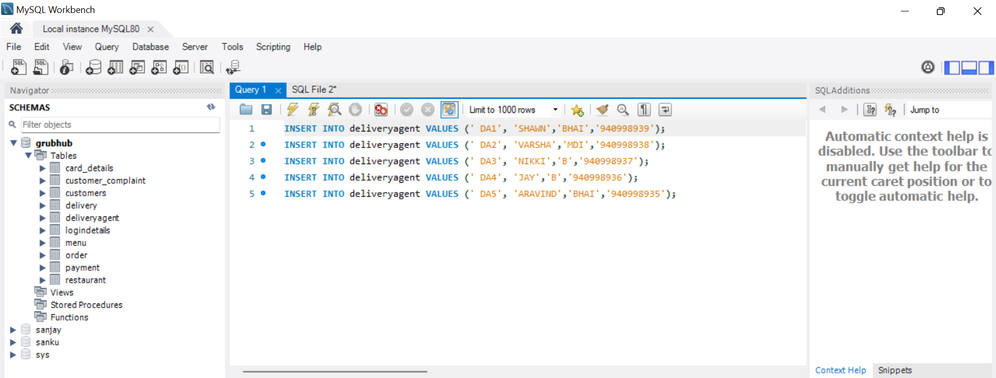

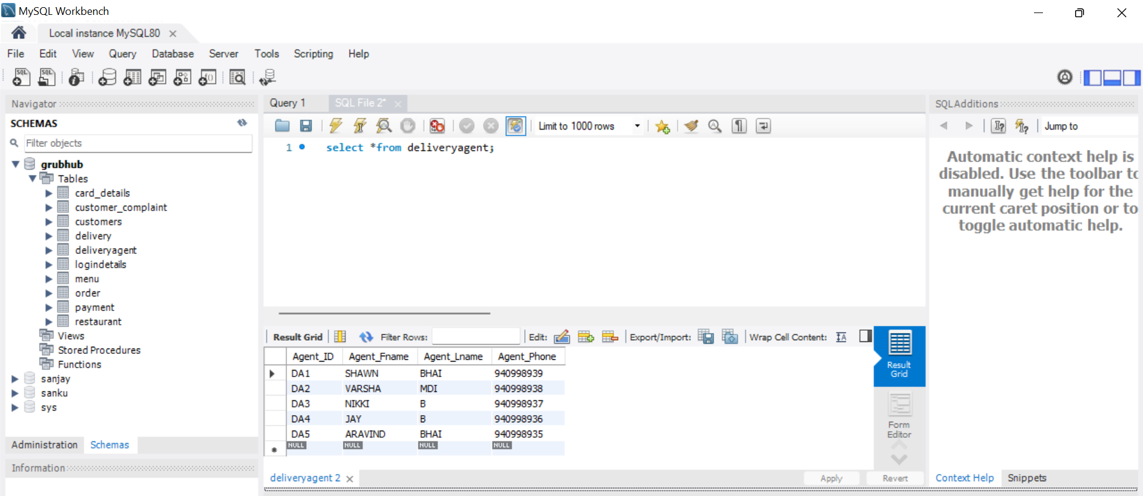

**Explanation:**  The above table shows the delivery agent details for the particular order.

**Card_Details Table :**

**Creating Table :**

CREATE TABLE Card_Details (

Card_ID varchar(255) NOT NULL,

Card_Type varchar(255) NOT NULL,

Card_Number varchar(255) NOT NULL,

Cardholder_Name varchar(255) NOT NULL,

Card_Expirydate varchar(255) NOT NULL,

Customer_ID varchar(255) NOT NULL,

PRIMARY KEY (Card_ID),

FOREIGN KEY (Customer_ID) REFERENCES Customers (Customer_ID));

**INSERTING DATA RECORDS INTO THE TABLE :**

INSERT INTO card_details VALUES ('11', 'AMEX','123456789123456','SURAJKUMAR','06/27','SU677');

INSERT INTO card_details VALUES ('12', 'VISA','987654321123456','Sreekar S','05/27','SR897');

INSERT INTO card_details VALUES ('13', 'DISCOVER','123456789654321','VASAVI','04/27','VA978');

INSERT INTO card_details VALUES ('14', 'MC','123456789123456','NEERAJ','03/27','NE678');

INSERT INTO card_details VALUES ('15', 'VISA','123456789659876','RAMYA','02/27','RA987');

**Screenshots of the Data :**

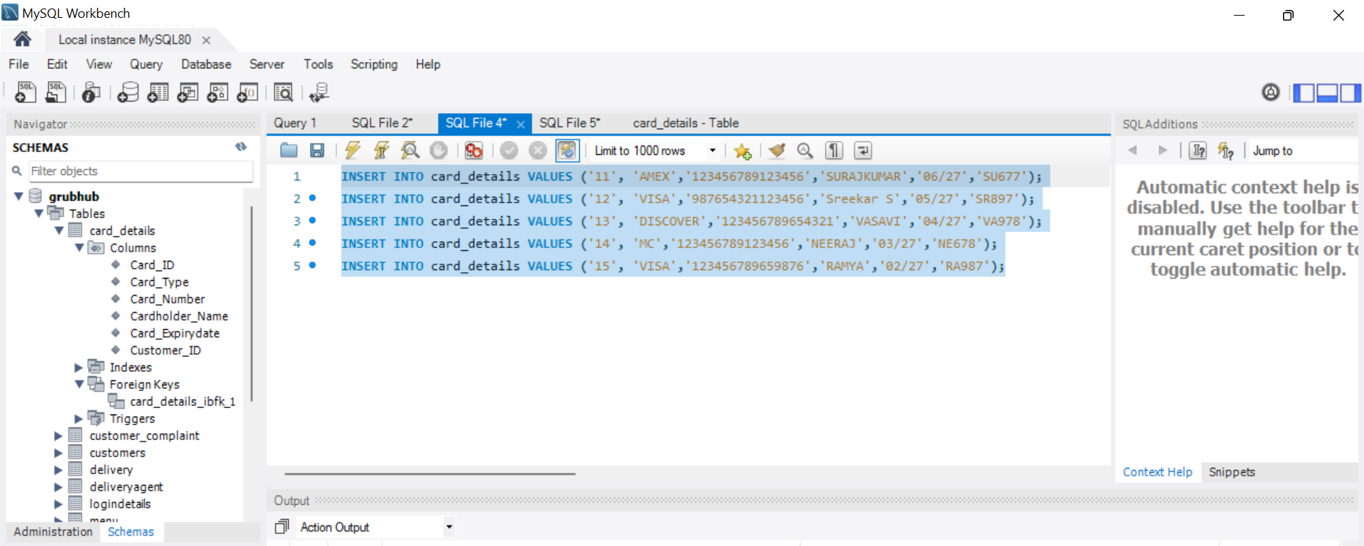

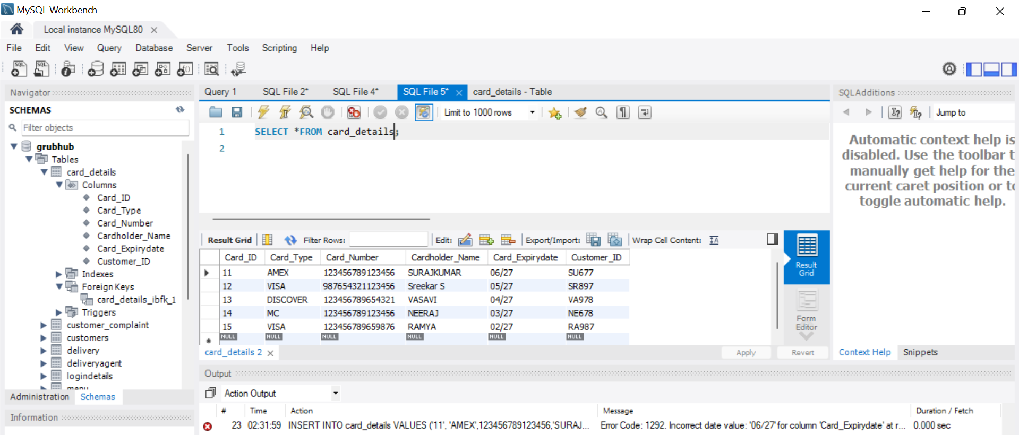

**Explanation:** The above table shows the details of card details through which we are doing payment.

**Payment Table:**

**Creating Table:**

CREATE TABLE Payment (

Payment_ID varchar(255) NOT NULL,

Payment_Amount varchar(255) NOT NULL,

Card_ID varchar(255) NOT NULL,

PRIMARY KEY (Payment_ID),

FOREIGN KEY ( Card_ID) REFERENCES Card_Details (Card_ID)

);

**INSERTING VALUES / RECORDS IN THE DATA:**

INSERT INTO payment VALUES ('111', '185$','11');

INSERT INTO payment VALUES ('112', '167.2$','12');

INSERT INTO payment VALUES ('113', '99.25$','13');

INSERT INTO payment VALUES ('114', '67$','14');

INSERT INTO payment VALUES ('115', '54$','15');

**SCREENSHOT OF THE DATA :**

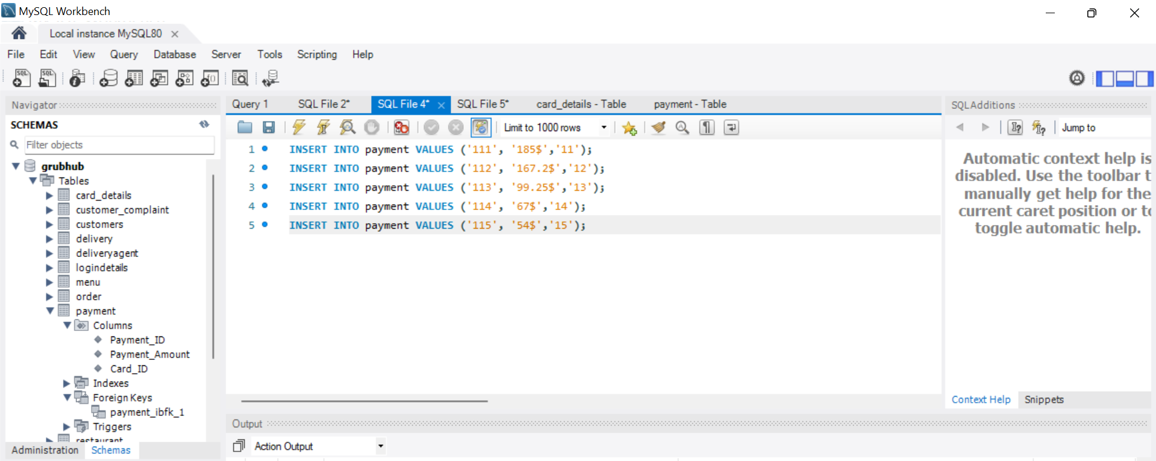

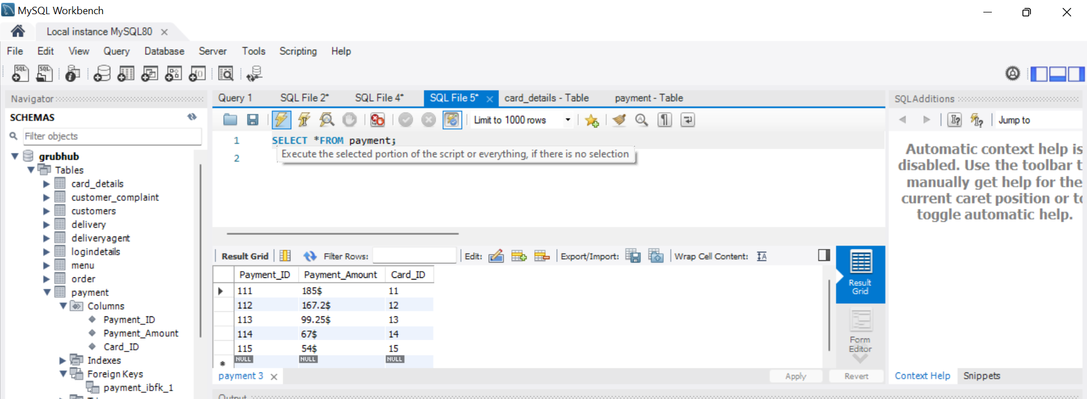

**Explanation**: The above table shows details of payment.

**DELIVERY TABLE:**

**CREATING TABLE:**

CREATE TABLE Delivery (

Delivery_ID varchar(255) NOT NULL,

Delivery_StartTime varchar(255) NOT NULL,

Delivery_EndTime varchar(255) NOT NULL,

Delivery_Status varchar(255) NOT NULL,

Customer_ID varchar(255) NOT NULL,

Agent_ID varchar(255) NOT NULL,

Restaurant_ID varchar(255) NOT NULL,

Order_ID varchar(255) NOT NULL,

PRIMARY KEY (Delivery_ID),

FOREIGN KEY (Customer_ID) REFERENCES Customers(Customer_ID),

FOREIGN KEY (Agent_ID) REFERENCES deliveryagent(Agent_ID));

alter table delivery add FOREIGN KEY (Restaurant_ID) REFERENCES restaurant(Restaurant_ID);

alter table delivery add FOREIGN KEY (Order_ID) REFERENCES orders(Order_ID);

**INSERTING DATA RECORDS :**

INSERT INTO Delivery value (1,'2022-08-01 10:20:20','2022-08-01 10:50:16','Delivered','SU677','DA2',RA1,1);

INSERT INTO Delivery value (2,'2022-08-01 11:45:45','2022-08-01 12:20:30','Delivered','DH543'','DA1','RA2',2);

INSERT INTO Delivery value (3,'2022-08-01 09:11:11','2022-08-01 09:30:45','Cancelled','DO876','DA2','RA1',6);

INSERT INTO Delivery value (4,'2022-08-01 08:20:20','2022-08-01 08:35:12','Incomplete','ZE876','DA3','RA3',10);

INSERT INTO Delivery value (4,'2022-08-01 14:51:19','2022-08-01 15:35:23','Delivered','MO4321','DA4','RA4',11);

**Screenshots Of the Data :**

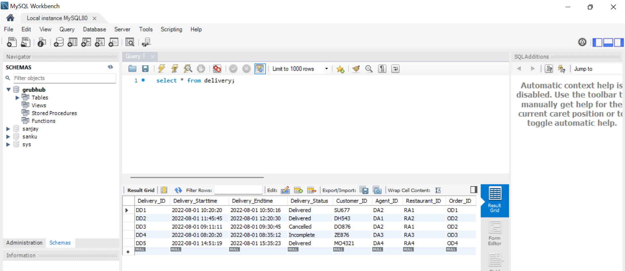

**Explanation:** The above table shows the details of delivery.

**Explanation:**

**MENU TABLE :**

**CREATING TABLE :**

CREATE TABLE Menu (

Menu_ID varchar(255) NOT NULL,

Menu_Name varchar(255) NOT NULL,

Menu_Type varchar(255) NOT NULL,

Menu_Price varchar(255) NOT NULL,

Order_ID varchar(255) NOT NULL,

PRIMARY KEY (Menu_ID),

FOREIGN KEY (Order_ID) REFERENCES orders(Order_ID));

**INSERTING VALUES / RECORDS IN THE DATA :**

INSERT INTO Menu values (022, 'Buffalo Chicken Supreme Pizza', 'Pizza', 12.00, OD2);

INSERT INTO Menu values (23, 'Buffalo Chicken Supreme Pizza', 'Pizza', 17.00, OD3);

INSERT INTO Menu values (24, 'Cheese', 'Specialty Pizza and Calzones', 14.00, OD4);

INSERT INTO Menu values (25, 'Chicken Broccoli Ziti', 'Specialty Pizza and Calzones', 20.00, OD5);

INSERT INTO Menu values (26, 'Preserved Egg with Chilled Tofu','Appetizers',12.95, OD26);

INSERT INTO Menu values (27, 'Clam Soup','Soup',11.95, OD6);

INSERT INTO Menu values (28, 'Almond Bubble Tea','Drinks',04.50,OD7);

INSERT INTO Menu values (29, 'Caesar Salad Bowl','Salad Bowls',06.49,OD8);

INSERT INTO Menu values (210, 'Meal for 6','Family Meals',46.49,OD9);

INSERT INTO Menu values (211, 'Flat White Coffee','Espresso',12.99,OD10);

INSERT INTO Menu values (212, 'Shawarma Salad','Fresh Salads',09.00,OD11);

INSERT INTO Menu values (213, 'House Tempura Burrito','Signature Sushi Burritos',10.00,OD12);

INSERT INTO Menu values (214, 'House veg Burrito','Signature Sushi Burritos',10.00,OD13);

INSERT INTO Menu values (215, 'Gulab_jamun','sweet',10.00,OD14);

INSERT INTO Menu values (216, 'Bread_halwa','sweet',8.00,OD15);

INSERT INTO Menu values (217, 'Mango_lassi','apetizer',4.99,OD16);

INSERT INTO Menu values (218, 'chicken_biryani','Biryani',9.99,OD17);

INSERT INTO Menu values (219, 'mutton_biryani','Biryani',12.99,OD18);

INSERT INTO Menu values (220, 'chicken_Boneless_biryani','Biryani',10.99,OD19);

**Screenshots Of the Data :**

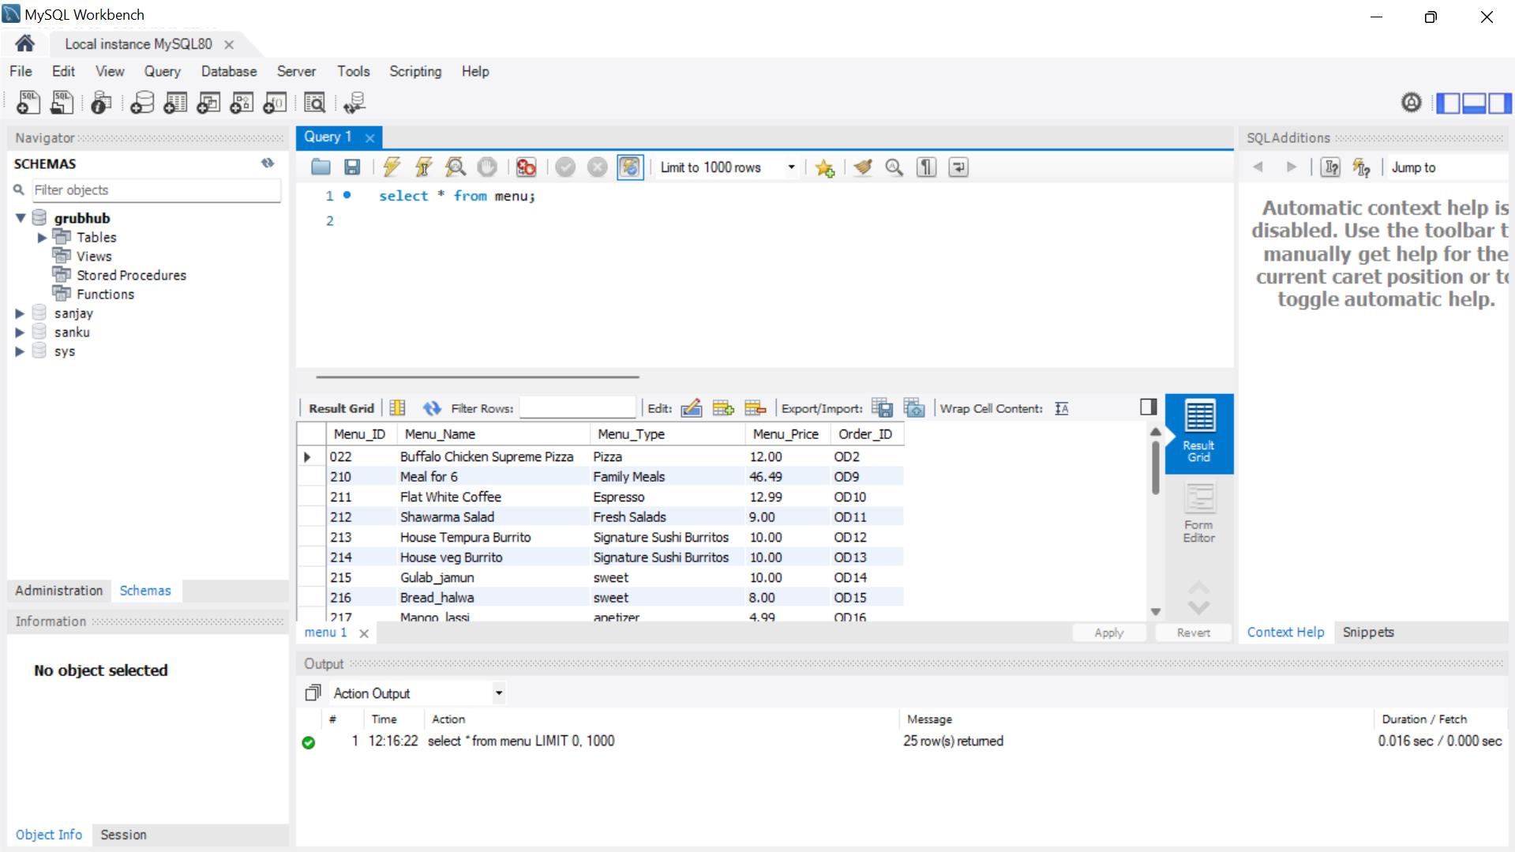

**Explanation:** The above table shows the menu details.

**Restaurant Table:**

**Creating Table:**

CREATE TABLE Restaurant (

Restaurant_ID varchar(255) NOT NULL,

Restaurant_Name varchar(255) NOT NULL,

Restaurant_OpenTime varchar(255) NOT NULL,

Restaurant_ClosingTime varchar(255) NOT NULL,

Restaurant_PhoneNumber int(255) NOT NULL,

Restaurant_Address varchar(255) NOT NULL,

Menu_ID varchar(255) NOT NULL,

Login_ID varchar(255) NOT NULL,

PRIMARY KEY (Restaurant_ID),

FOREIGN KEY (Menu_ID) REFERENCES menu(Menu_ID),

FOREIGN KEY (Login_ID) REFERENCES LoginDetails(Login_ID)

);

**INSERT RECORDS / VALUES IN THE DATA :**

INSERT INTO Restaurant VALUES ('RA1','JIB', '8:00:00AM','10:00:00PM','7993243567','328 west university drive','23', 'GJ452');

INSERT INTO Restaurant VALUES ('RA2','KFC', '9:00:00AM','9:00:00PM','6793243567','458 west university drive','24','NEW1234');

INSERT INTO Restaurant VALUES ('RA3','Fuzzys', '8:00:00AM','12:00:00PM','4657890753','union circle denton','25', 'GO765');

INSERT INTO Restaurant VALUES ('RA4','saregama', '08:30:00AM','08:00:00PM','7654278963','567 highway street','26', 'SU5321');

INSERT INTO Restaurant VALUES ('RA5','chipotle', '08:00:00AM','05:00:00PM','24579034699','fountains of denton','27', 'ZE876');

INSERT INTO Restaurant VALUES ('RA6','crooked crust', '09:00:00AM','10:00:00PM','3456789234','Avenue c','28', 'NEE654');

INSERT INTO Restaurant VALUES ('RA7','clark bakery', '09:00:00AM','09:00:00PM','87652456789','532 eagle drive','29', 'NEE654');

INSERT INTO Restaurant VALUES ('RA8','pizza hut', '08:30:00AM','09:00:00PM','609875247788','mark of denton12','210', 'ZE876');

INSERT INTO Restaurant VALUES ('RA9','miyano', '10:00:00AM','10:00:00PM','78935678934','671 wood hill street','211', 'NEE654');

INSERT INTO Restaurant VALUES ('RA10','taco casa', '08:00:00AM','05:00:00PM','2335677891','123 hilltop denton','212','GO765');

INSERT INTO Restaurant VALUES ('RA11','taco bell', '08:30:00AM','06:00:00PM','876543289','520 carroll street','213', 'GJ452');

INSERT INTO Restaurant VALUES ('RA12','hello india', '08:30:00AM','09:00:00PM','986224699','ioof street','214', 'GJ452');

INSERT INTO Restaurant VALUES ('RA13','india bazar', '08:30:00AM','08:00:00PM','6789054323','788 women university street','215', 'SU5321');

INSERT INTO Restaurant VALUES ('RA14','desi foods', '08:30:00AM','08:00:00PM','56809643223','epoch street','216', 'SU5321');

INSERT INTO Restaurant VALUES ('RA15','desi district', '08:30:00AM','08:00:00PM','3456789234','321 stella street','217', 'DH543');

**Screenshot For the Data :**

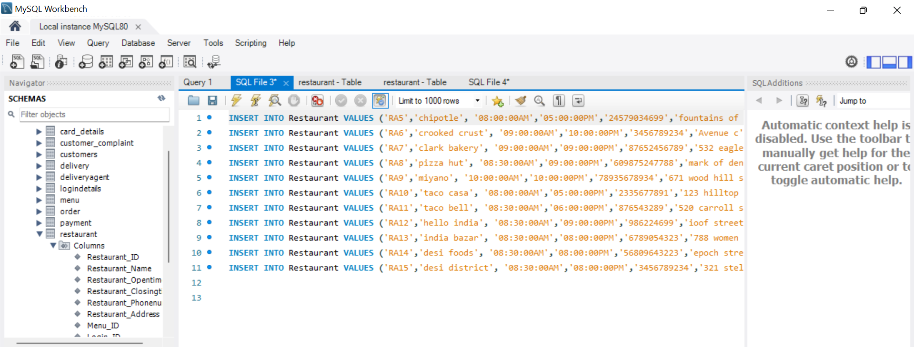

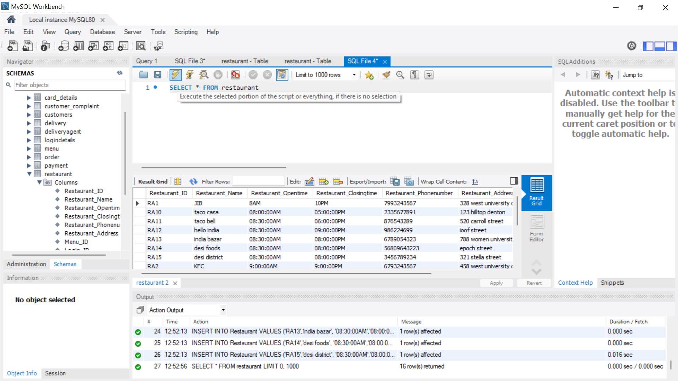

**Explanation:** The above table shows the details of restaurant.

**Order Table:**

**Create Table:**

CREATE TABLE orders (

Order_ID varchar(255) NOT NULL,

Order_Total int(255) NOT NULL,

Order_Timestamp varchar(255) NOT NULL,

Order_Status varchar(255) NOT NULL,

Payment_ID varchar(255) NOT NULL,

PRIMARY KEY ( Order_ID),

FOREIGN KEY (Payment_ID) REFERENCES Payment(Payment_ID)

);

**INSERT VALUES/ RECORDS IN TABLE :**

INSERT INTO Order values (1,20.00,'2022-08-01 11:20:20','Delivered',111);

INSERT INTO Orders values (2,50.50,'2022-08-02 12:20:20','preparing',111);

INSERT INTO Orders values (3,50.00,'2022-08-02 10:20:20','Received',112);

INSERT INTO Orders values (4,20.00,'2022-08-02 02:20:20','Confirmed',114);

INSERT INTO Orders values (5,26.00,'2022-08-03 01:20:20','out-for-delivery',114);

INSERT INTO Orders values (6,29.00,'2022-08-03 11:10:20','Received',115);

INSERT INTO Orders values (7,27.00,'2022-08-03 11:15:15','preparing',112);

INSERT INTO Orders values (8,22.00,'2022-08-04 09:10:20','Confirmed',113);

INSERT INTO Orders values (9,19.00,'2022-08-04 11:10:20','preparing',113);

INSERT INTO Orders values (10,9.99,'2022-08-04 08:10:20','Received',115);

INSERT INTO Orders values (11,9.99,'2022-08-04 10:10:20','Out-for-delivery',111);

INSERT INTO Orders values (12,10.23,'2022-08-04 14:15:20','Received',113);

INSERT INTO Orders values (13,8.66,'2022-08-04 18:05:20','Confirmed',112);

INSERT INTO Orders values (14,4.99,'2022-08-04 17:13:20','preparing',113);

INSERT INTO Orders values (15,14.99,'2022-08-04 16:33:20','preparing',114);

**Screenshot of the data:**

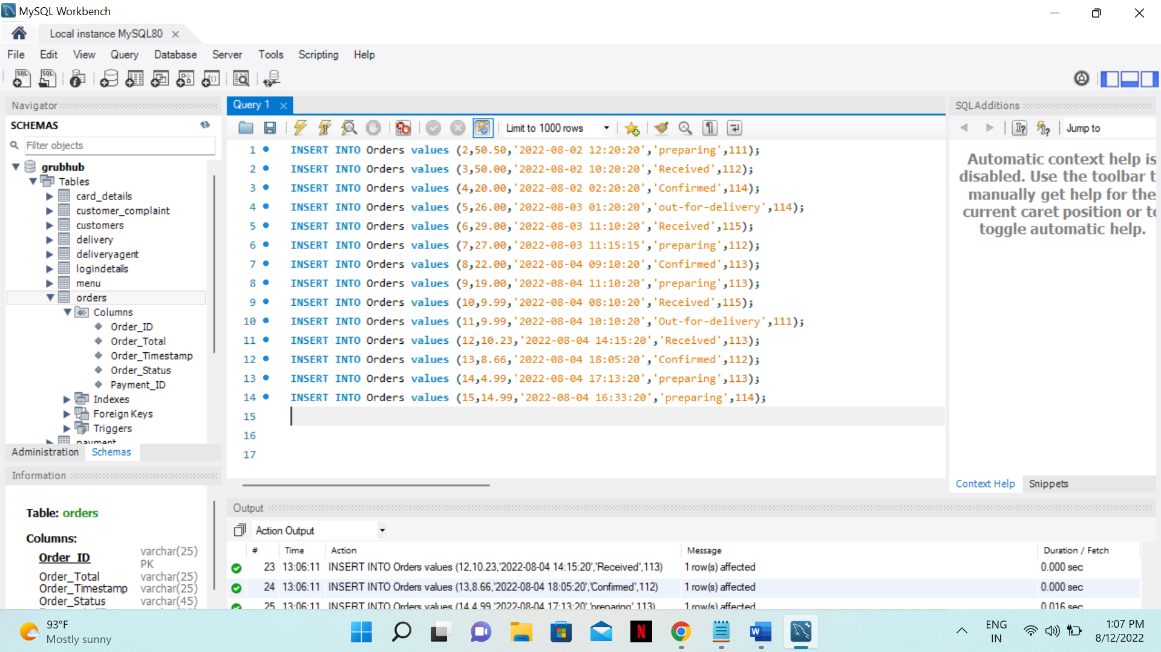

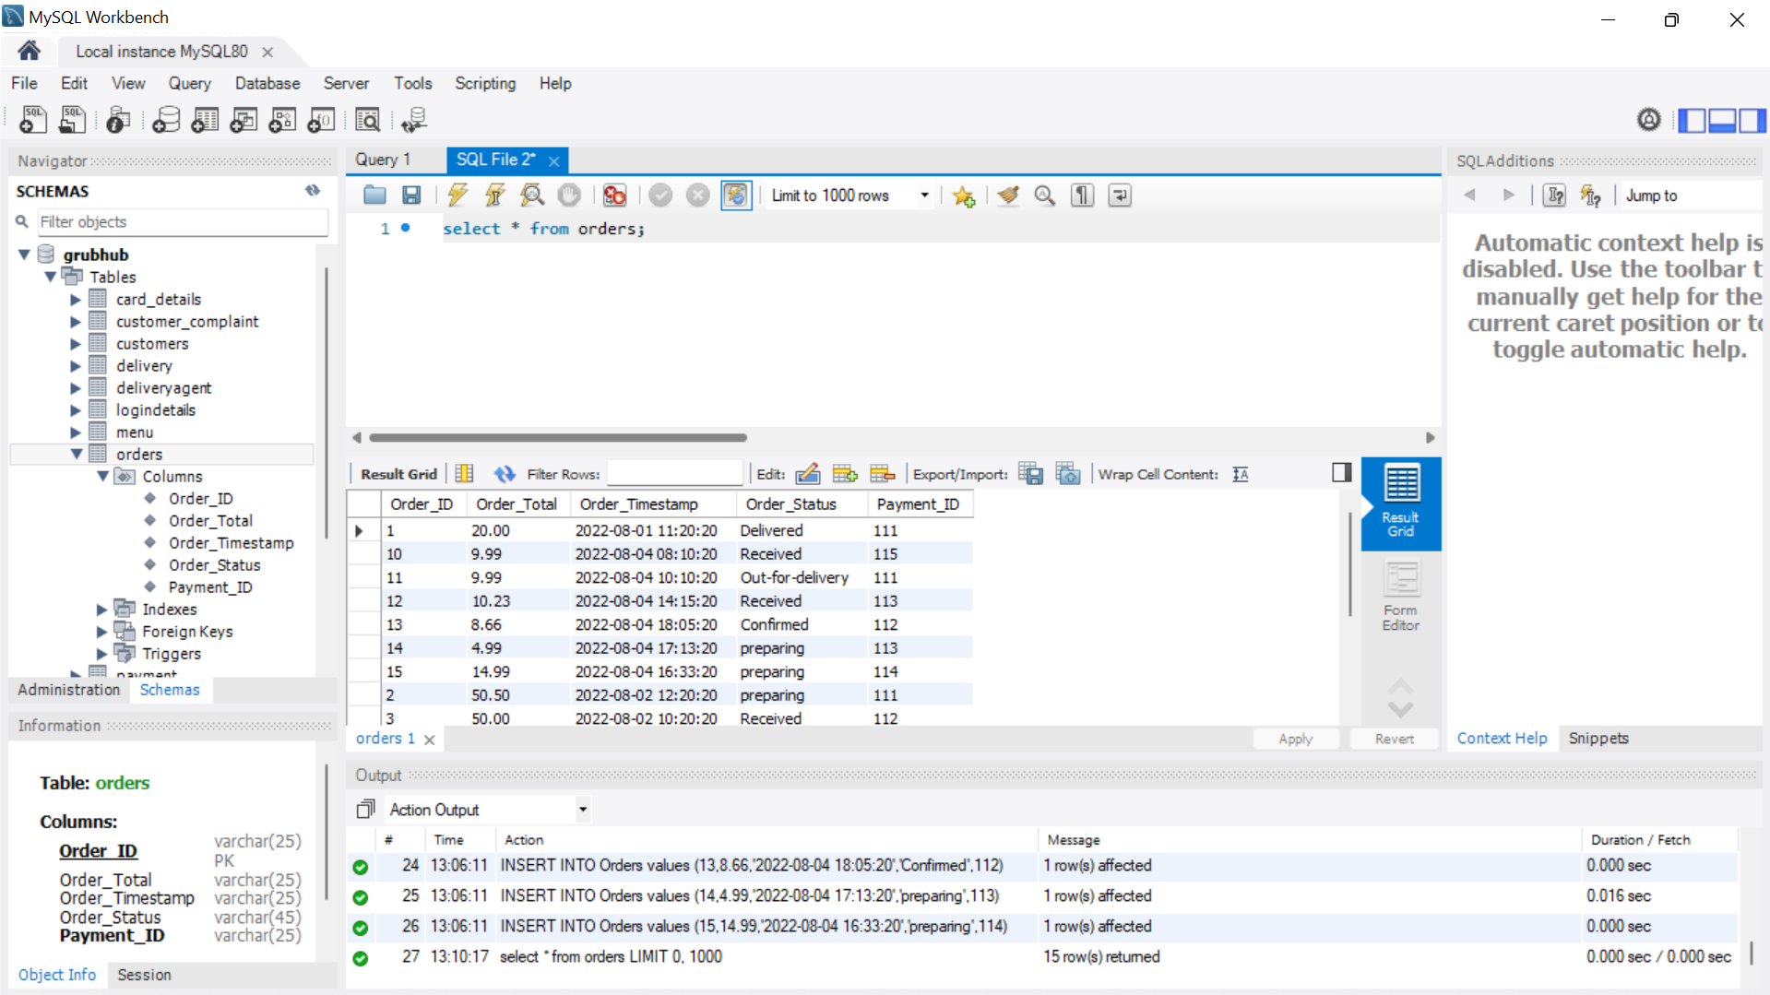

**QUERIES:**

**QUESTION -1:**

**1)Make a list of MAINDISH OR BIRYANI menu type items with menu ID, name, and price in the $4–$20 range.**

**Answer:**

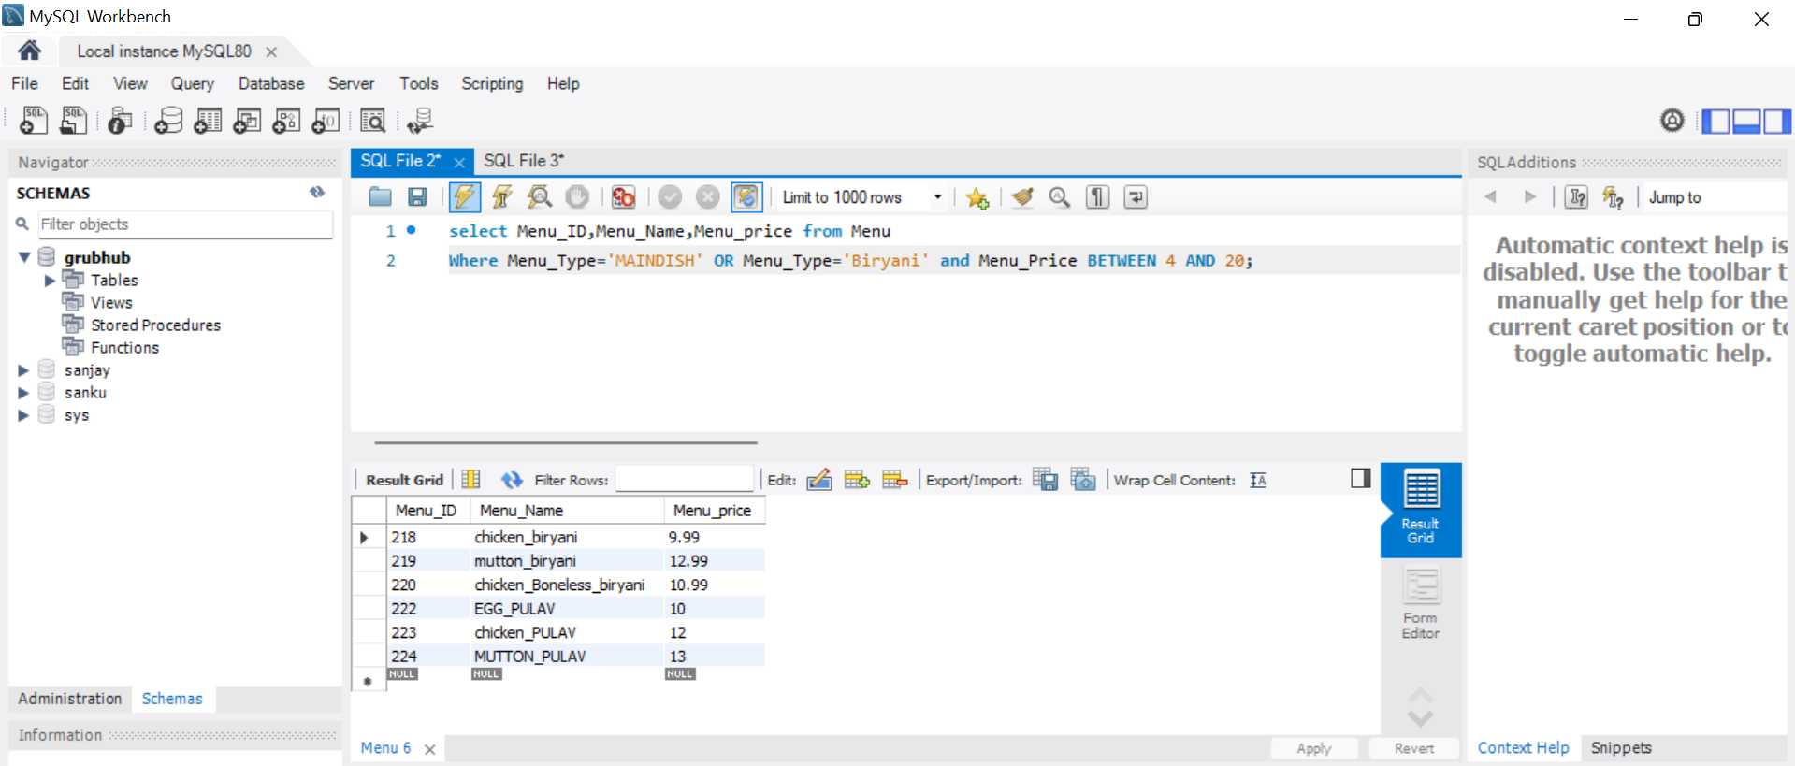

**Explanation:** In the particular price range of particular menu items, there are 6 dishes. To obtain the desired output in this query, we applied the between operator to the Menu_Price parameter in the Menu table.

**Question -2:**

**2)** **Information about the clients who have complained about food QUALITY ISSUE or MISSING ITEM?**

**Answer:**

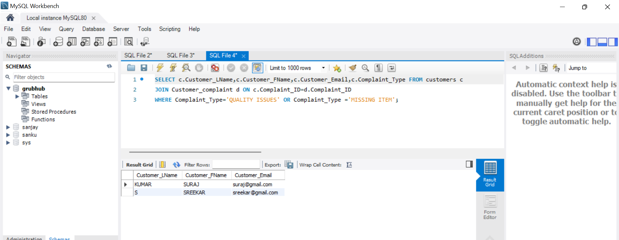

**Explanation:** We have 2 clients that are experiencing issues with quality or missing items. This information was retrieved by applying the condition to the kind of complaint in the customer complaint table and by linking it to the customer database to obtain the relevant client information.

**Question -3**

**3)Determine how many purchases were made using a Visa card.**

**Answer:**

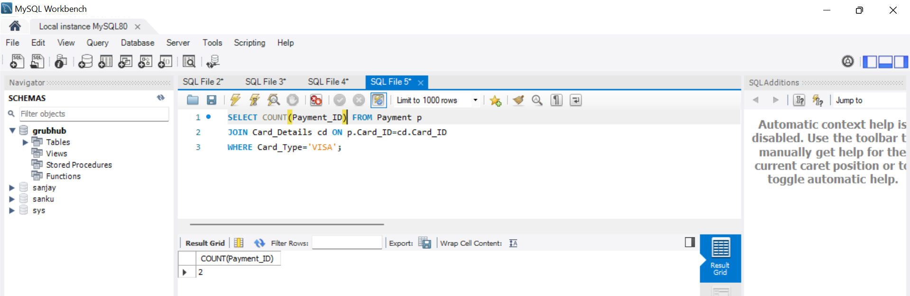

**Explanation:** There were only two payments made using a Visa card. Applying the count to the payment id in the payment table and specifying the particular card_type by connecting the card details and Payment table through the card id produced the desired result.

**QUESTION-4**

**4)** **List all Information of the restaurant, which opens on or after 8 AM and closes on or before 10 PM?**

**Answer:**

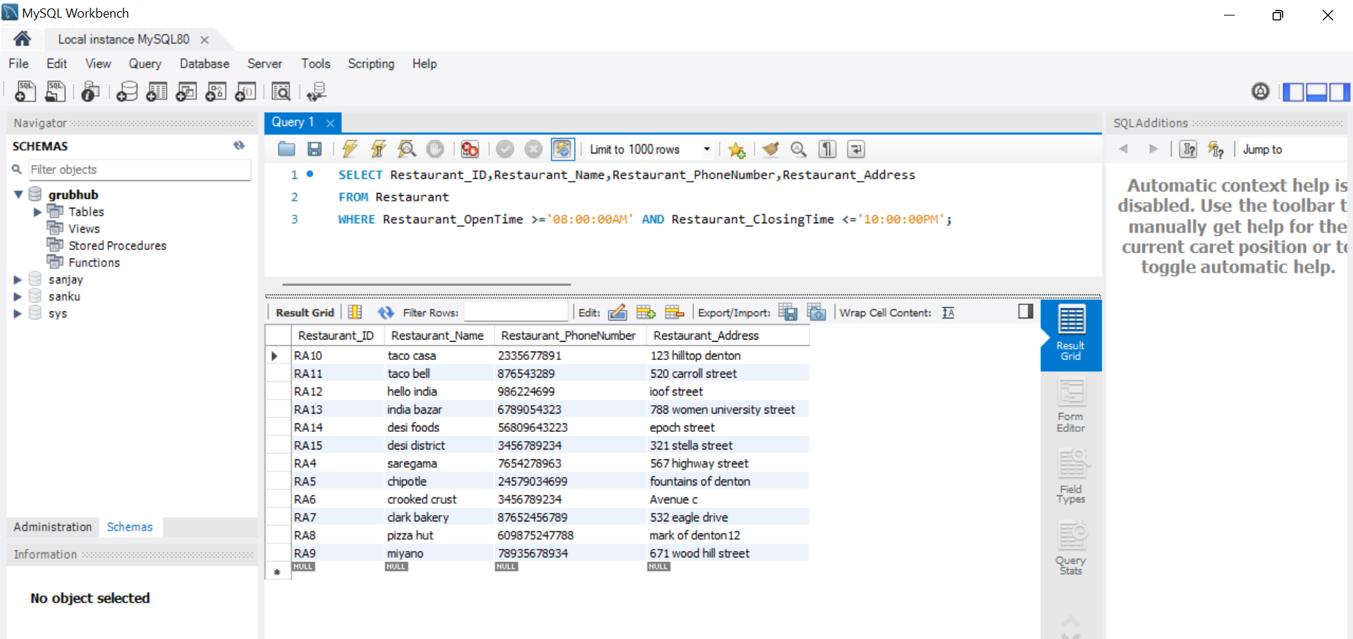

**Explanation:** Applying the condition to the Restaurant_OpeningTime property in the restaurant table allowed us to obtain the list of restaurants that are open after 8 o'clock.

**QUESTION-5**

**5)** **Show the data of pizzas and Sweet in the Menu and sort the data by price.**

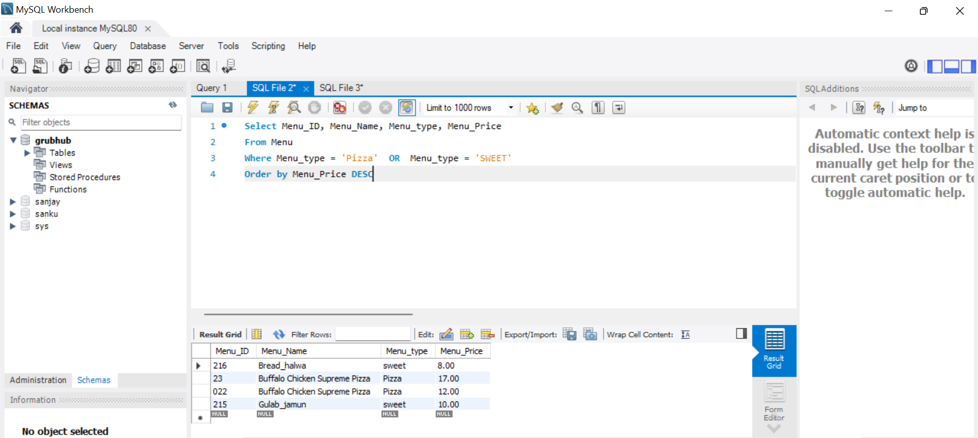

**Explanation:** The condition was applied to the Menu_Type in the Menu Table, and then the ORDER BY condition was applied to the Menu_Price in the same table to acquire the data.

**Conclusion:**

We have made a food ordering system. It will help the restaurant to do all the functionalities more accurately and in a faster way and to maintain records, as many restaurants do that in a manual way. Users will register and log in to the system then place an order from the menu of the restaurant the app will manage all the processes of taking the order, payment, and process the order. Users can also view order history and edit their profile details.